**Program 2 (Boundary analysis for Commision program)**

**/* Design. develop, code and run the program in nay suitable language to solve the commission problem. Analyze it from the perspective of boundary value, derive test cases, execute these test cases and discuss the test results */**

**/* Assumption price for lock=45.0, stock=30.0 and barrels=25.0 production limit could sell in a**

**month 70 locks,80 stocks and 90 barrels commission on sales = 10 % <= 1000 and 15 % on 1000 to 1800 and 20 % on above 1800*/**

PROGRAM:

#include<stdio.h>

int main()

{

// Anirudh Krishnaprasad 1CR18IS017

int locks, stocks, barrels, tlocks, tstocks, tbarrels;

float lprice, sprice, bprice, sales, comm;

int c1,c2,c3,temp;

lprice=45.0;

sprice=30.0;

bprice=25.0;

tlocks=0;

tstocks=0;

tbarrels=0;

printf("\nEnter the number of locks and to exit the loop enter -1 for locks\n");

scanf("%d",&locks);

while(locks!=-1)

{

c1=(locks<=0||locks>70);

printf("Enter the number of stocks and barrels\n");

scanf("%d%d",&stocks,&barrels);

c2=(stocks<=0||stocks>80);

c3=(barrels<=0||barrels>90);

if(c1)

printf("Value of locks not in the range 1..70 ");

else

{

temp=tlocks+locks;

if(temp>70)

printf("New total locks =%d not in the range 1..70 so old ",temp);

else

tlocks=temp;

}

printf("Total locks = %d\n",tlocks);

if(c2)

printf("Value of stocks not in the range 1..80 ");

else

{

temp=tstocks+stocks;

if(temp>80)

printf("New total stocks =%d not in the range 1..80 so old ",temp);

else

tstocks=temp;

}

printf("Total stocks=%d\n",tstocks);

if(c3)

printf("Value of barrels not in the range 1..90 ");

else

{

temp=tbarrels+barrels;

if(temp>90)

printf("new total barrels =%d not in the range 1..90 so old ",temp);

else

tbarrels=temp;

}

printf("Total barrel = %d",tbarrels);

printf("\nEnter the number of locks and to exit the loop enter -1 for locks\n");

scanf("%d",&locks);

}

printf("\nTotal locks = %d\nTotal stocks = %d\nTotal barrels = %d\n",tlocks,tstocks,tbarrels);

sales = lprice*tlocks+sprice*tstocks+bprice*tbarrels;

printf("\nThe total sales = %f\n",sales);

if(sales > 0)

{

if(sales > 1800.0)

{

comm=0.10*1000.0;

comm=comm+0.15*800;

comm=comm+0.20*(sales-1800.0);

}

else if(sales > 1000)

{

comm =0.10*1000;

comm=comm+0.15*(sales-1000);

}

else

comm=0.10*sales;

printf("The commission is = %f\n",comm);

}

else

printf("There is no sales\n");

return 0;

}

Screenshot of the program:

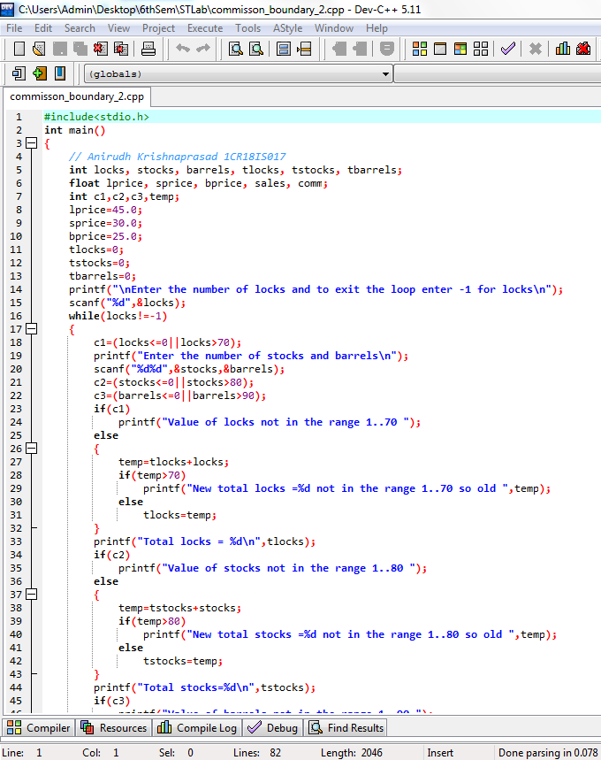

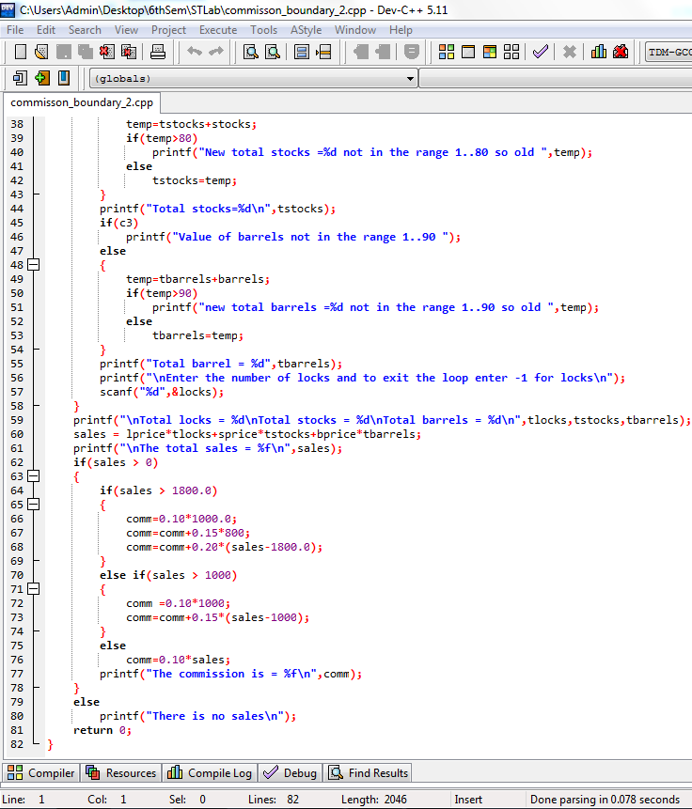

Screenshots:

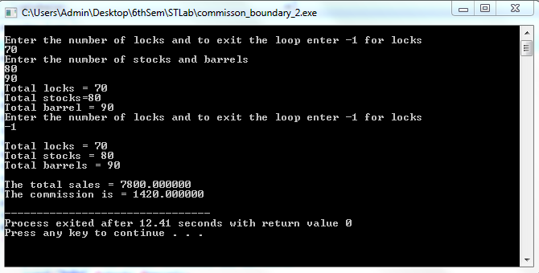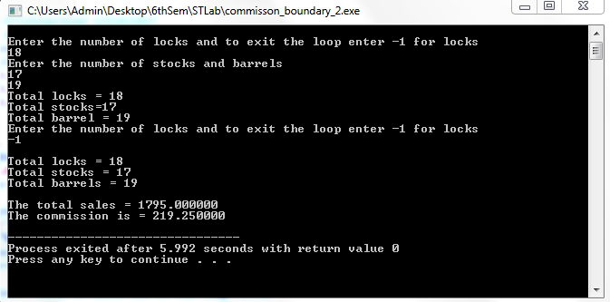

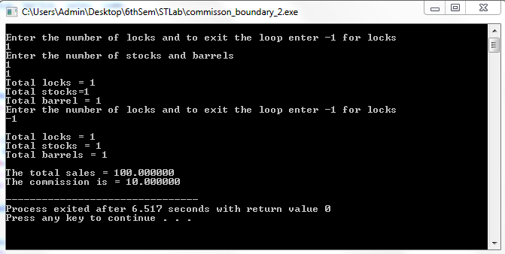

INPUT CASES :

**Commission Problem Output Boundary Value Analysis Cases**

|  |  |  |  |  |  |  |  |  |  |  |
| --- | --- | --- | --- | --- | --- | --- | --- | --- | --- | --- |
| ID  NO. | Description | Input Data | | | Expected Output | | Actual output | | Status | Comments |
| Total locks | Total Stocks | Total barrels | Sales | Comm-  issions | Sales | Comm-  issions |
| 1 | Enter the min value for locks, stocks and barrels | 1 | 1 | 1 | 100 | 10 | 100 | 10 | Done | output minimum |
| 2 | Enter the min value for 2 items and min +1 for  any one item | 1 | 1 | 2 | 125 | 12.5 | 125 | 12.5 | Done | output minimum+ |
| 3 | 1 | 2 | 1 | 130 | 13 | 130 | 13 | Done | output minimum+ |
| 4 | 2 | 1 | 1 | 145 | 14.5 | 145 | 14.5 | Done | output minimum+ |
| 5 | Enter the value sales approximately mid value  between 100 to 1000 | 5 | 5 | 5 | 500 | 50 | 500 | 50 | Done | Midpoint |
| 6 | Enter the values to calculate the commission for  sales nearly less than 1000 | 10 | 10 | 9 | 975 | 97.5 | 975 | 97.5 | Done | Border point- |
| 7 | 10 | 9 | 10 | 970 | 97 | 970 | 97 | Done | Border point- |
| 8 | 9 | 10 | 10 | 955 | 95.5 | 955 | 95.5 | Done | Border point- |
| 9 | Enter the values sales exactly equal to 1000 | 10 | 10 | 10 | 1000 | 100 | 1000 | 100 | Done | Border point |
| 10 | Enter the values to calculate the commission for  sales nearly greater than 1000 | 10 | 10 | 11 | 1025 | 103.75 | 1025 | 103.75 | Done | Border point+ |
| 11 | 10 | 11 | 10 | 1030 | 104.5 | 1030 | 104.5 | Done | Border point+ |
| 12 | 11 | 10 | 10 | 1045 | 106.75 | 1045 | 106.75 | Done | Border point+ |
| 13 | Enter the value sales approximately mid value between 1000 & 1800 | 14 | 14 | 14 | 1400 | 160 | 1400 | 160 | Done | Midpoint |
| 14 | Enter the values to calculate the commission for  sales nearly less than 1800 | 18 | 18 | 17 | 1775 | 216.25 | 1775 | 216.25 | Done | Border point - |
| 15 | 18 | 17 | 18 | 1770 | 215.5 | 1770 | 215.5 | Done | Border point - |
| 16 | 17 | 18 | 18 | 1755 | 213.25 | 1755 | 213.25 | Done | Border point - |
| 17 | Enter the values sales exactly equal to 1800 | 18 | 18 | 18 | 1800 | 220 | 1800 | 220 | Done | Border point |
| 18 | Enter the values to calculate the commission for  sales nearly greater than 1800 | 18 | 18 | 19 | 1825 | 225 | 1825 | 225 | Done | Border point + |
| 19 | 18 | 19 | 18 | 1830 | 226 | 1830 | 226 | Done | Border point + |
| 20 | 19 | 18 | 18 | 1845 | 229 | 1845 | 229 | Done | Border point + |
| 21 | Enter the values normal value for lock, stock and  barrel | 48 | 48 | 48 | 4800 | 820 | 4800 | 820 | Done | Midpoint |
| 22 | Enter the max value for 2 items and max - 1 for  any one item | 70 | 80 | 89 | 7775 | 1415 | 7775 | 1415 | Done | Output maximum - |
| 23 | 70 | 79 | 90 | 7770 | 1414 | 7770 | 1414 | Done | Output maximum - |
| 24 | 69 | 80 | 90 | 7755 | 1411 | 7755 | 1411 | Done | Output maximum - |
| 25 | Enter the max value for 2 items and max - 1 for  any one item | 70 | 80 | 90 | 7800 | 1420 | 7800 | 1420 | Done | Output maximum |

Output Special Values Test Cases

|  |  |  |  |  |  |  |  |  |  |  |
| --- | --- | --- | --- | --- | --- | --- | --- | --- | --- | --- |
| Case  ID: | Description | Input Data | | | Expected Output | | Actual Output | | Status | Comments |
| Total  Locks | Total Stocks | Total Barrels | Sales | Commi-  ssions | Sales | Commi-  ssions |
| 1 | Enter the random values such that to calculate  commission for sales nearly less than 1000 | 11 | 10 | 8 | 995 | 99.5 | 995 | 99.5 | Done | Border point- |
| 2 | Enter the random values such that to calculate  commission for sales nearly greater than 1000 | 10 | 11 | 9 | 1005 | 100.75 | 1005 | 100.75 | Done | Border point+ |
| 3 | Enter the random values such that to calculate  commission for sales nearly less than 1800 | 18 | 17 | 19 | 1795 | 219.25 | 1795 | 219.25 | Done | Border point- |
| 4 | Enter the random values such that to calculate  commission for sales nearly greater than 1800 | 18 | 19 | 17 | 1805 | 221 | 1805 | 221 | Done | Border point+ |